**Risk Stratification for Population Health Management**

New care models

**Vanguard learning product**

September 2017



# Contents

Contents 1

1 The issue **Error! Bookmark not defined.**

2 The intervention chosen **Error! Bookmark not defined.**

3 How it was implemented **Error! Bookmark not defined.**

4 Impact **Error! Bookmark not defined.**

5 Conditions for success **Error! Bookmark not defined.**

6 Learning from key challenges 13

7 Key contact for further information 17

8 Link to useful resources 16

Our values: clinical engagement, patient involvement, local ownership, national support written at bottom left.
www.england.nhs.uk/vanguards written at bottom left.
Hashtag futureNHS written at bottom right.

Date

**Contents**

Contents 2

1 About 3

2 Why use this product 3

3 Five minute guide 4

4 Advanced options 5

5 Learning from key challenges 13

6 Other useful resources 16

7 Glossary 17

8 Key contact information 17

**About vanguard learning products**

The vanguard learning products are a selection of the key learnings from the vanguard programme. They have been developed in conjunction with vanguard sites and national arm’s length bodies and aim to provide a series of short practical guides to those wanting to implement specific elements of the vanguard programme. The product in this document will also be made available on the vanguard learning site, this and other products is accessible via <https://future.nhs.uk>.

# About

As part of the New Care Models programme, some vanguard sites have implemented risk stratification to support population health management. Newly announced Accountable Care Systems will also aim to analyse and proactively manage the needs of their local population.

This product draws on the learning from vanguard sites to offer advice and guidance to staff within local healthcare systems who want to find out more about how risk stratification can be used to support population health management.

The guide includes:

* An introduction to risk stratification and population health management.
* Examples of risk stratification for population health management in practice in vanguard sites, including tools, methods and outcomes.
* Collective lessons learned across vanguards that have used risk stratification for population health management.
* An overview of the three NHS predictive modelling tools in risk stratification.
* Links to other key resources, including:
  + Evidence for risk stratification as a tool for supporting care planning and personalised care.
  + A learning and impact study on risk stratification.
  + A case study on the use of risk stratification to identify patients who are potentially suitable for extensive care and enhanced primary care.

# Why use this product and who is it for?

This product is useful for staff within local healthcare systems, particularly aspiring Accountable Care Systems, who are aiming to analyse and proactively manage the needs of their local population. This may include:

* Commissioners and commissioning support organisations, looking to purchase risk stratification tools to support effective population health management.
* Regional system leaders and transformers, seeking to improve local healthcare systems.
* Central policy makers, seeking to draw lessons from existing projects for future policy.
* System leaders and transformers, to improve local or regional healthcare systems.
* Clinicians and local analysts, to learn technical lessons from the vanguards.

Risk stratification can support effective and proactive management of the local population’s healthcare, enabling more efficient use of the local population’s healthcare budget and better outcomes for local people.

# Five minute guide

Population health management is the analysis and segmentation of the needs of a population and the design of clinical and other interventions to prevent illness or acute deterioration.

End state accountable care systems and vanguards will have a complete understanding of their population and be proactively managing care based on that information. This distinguishes them from the majority of other systems who are managing care reactively.

Population health management is not a new concept, but it is yet to be consistently implemented in systems across England. We are supporting the accountable care systems and vanguards to implement systematic and validated population health management approaches.

Figure 1:

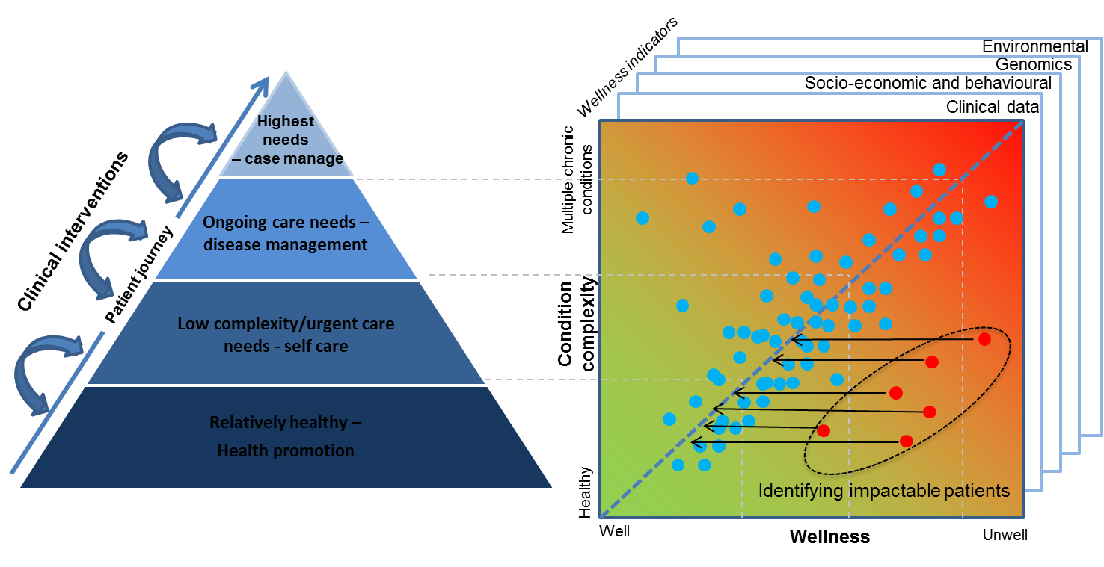

**Risk stratification – identifying the cost:**

Risk stratification segments the population and attributes cost, enabling the system to identify greatest opportunities for changing the delivery of care.

Figure 2:

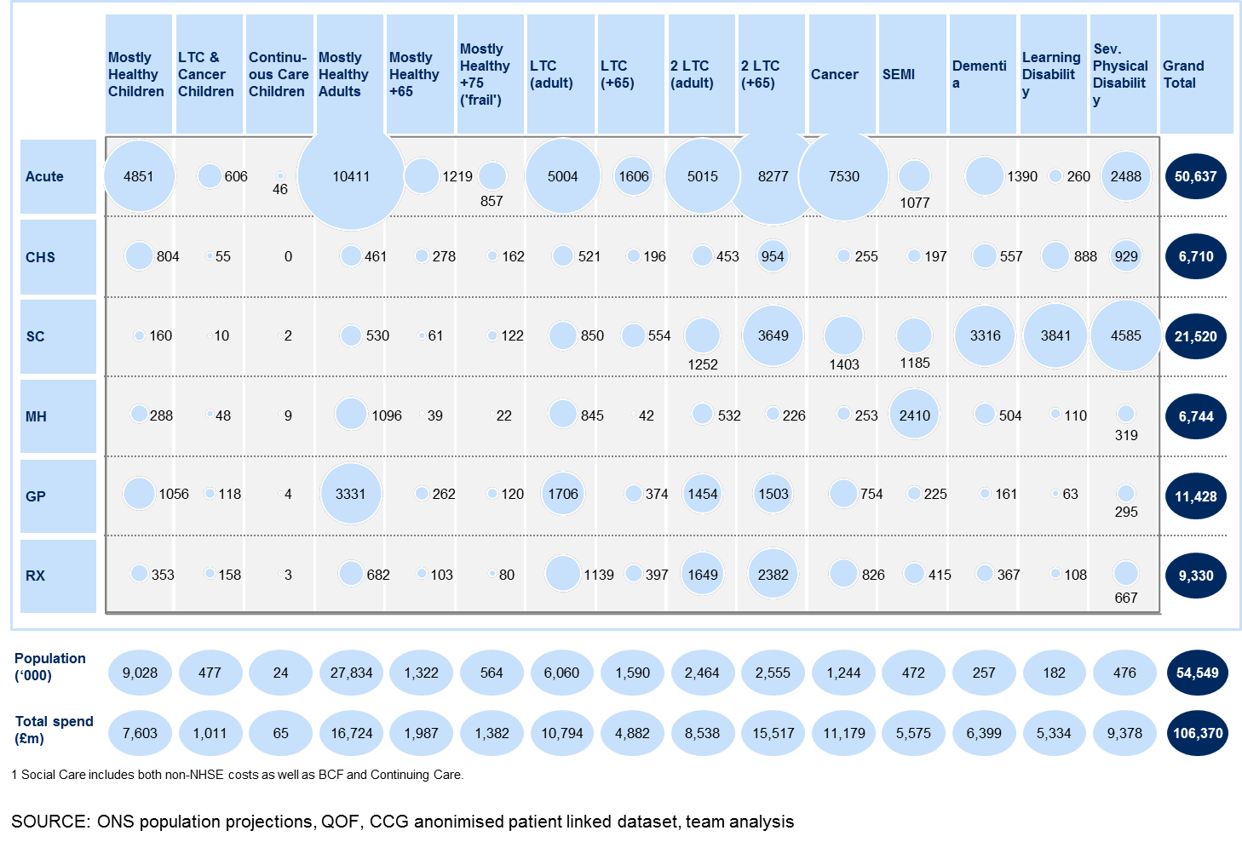

There are several different methods of risk stratification to support population health management.

# Advanced options

**Reducing the risk – redesigning the care model**

Risk stratification is only as effective as the interventions people are referred on to. Even the most accurate predictor of the impact of risk will be limited if the proactive interventions do not effectively reduce an individual’s risk of emergency admission/ other outcome.

1. **Principa:** Principia vanguard uses the GP Repository for Clinical Care (GPRCC) to regularly review patients who may be at risk of being admitted to hospital, have severe COPD or heart failure, for example. On the basis of this information, a number of services have been introduced including proactive case finding of patients with atrial fibrillation using pulse checks and AliveCor devices. This has resulted in 28 fewer strokes per year and 9 fewer deaths per year.
2. **Southern Hampshire:** Southern Hampshire has worked with Milliman to forecast 5 year activity and expenditure. This data was benchmarked against a ‘well managed’ health care system from the USA, which demonstrated that one of the highest areas of need was related to respiratory conditions. The Carousel Clinics for patients with respiratory conditions have reviewed 1,436 patients, of which 460 were poorly controlled; hospital admissions have reduced from 6 to 0 and GP emergency appointments from 61 to 31.

**Risk stratification in practice**

1. **Dudley MCP:** Dudley MCP uses Risk stratification tools and MDT list review to case find and treat high risk patients. Currently exploring Poly-characteristic modelling to enhance targeted interventions.

**Geographical area:** Dudley West Midlands

**Purpose:** One of the objectives of the MCP model is to focus on screening, prevention, early diagnosis and pro-active management of risk factors. At the centre of the model are practice based Multi-disciplinary Teams.

**Method:**

* Dudley Vanguard now has all of its GP practices using the same system (EMIS Web) and incorporated within this system is the Q-Admissions Risk Stratification Tool.
* It allows GPs and MDT’s to identify cohorts of patients to be identified by risk of emergency admissions and event flagging. The first year of the Dudley GP Outcomes Framework (replacement QOF) is underway which measures many factors supporting risk stratification and associated interventions.
* MDT’s include GPs, Practice Based Pharmacists, District Nurses, Mental Health Nurses, Care Coordinators, Social Care Workers and ‘Integrated Plus’ (voluntary sector).

**Outcomes:**

* Dudley Vanguard has implemented a range of services in developing the platform for the MCP (currently in competitive dialogue phase of procurement).
* MDT’s have been augmented by other schemes including ‘Integrated Plus’, Care Coordinator Service, Self-management apps and kiosks, Falls and Fracture Prevention Service, Care Home Telemedicine, and Practice Based Pharmacists. As an example, the Integrated Plus service reduced admissions via A&E by 7%. Below is a case study of a patient under the care of the MDT.

**Figure 3:**

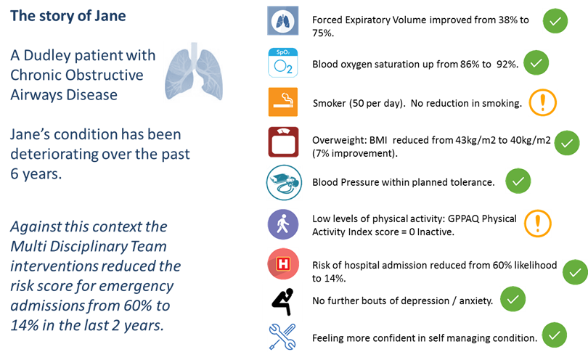

1. **Prinicipa MCP:** Principia use clinical judgement and threshold modelling to establish risk per segment of the population identified, enabling clinicians to make more informed decisions about patient risk.

**Geographical area:** South Nottinghamshire

**Purpose:** One of the objectives of the MCP model is to focus on prevention, early diagnosis and management of risk factors, as well as targeting resources more efficiently based on detailed understanding of population need.

**Method:**

* Principia vanguard uses the GP Repository for Clinical Care (GPRCC) that creates a consolidated view of data sources from primary care, secondary care, mental health, and community care.
* It allows GP practices to regularly review these patients who may, for example: be at risk of being admitted to hospital, be on an End of Life register, have severe COPD or Heart failure, to ensure that these patients are receiving the correct level of care.
* Local care teams that deliver services to these patients such as community nurses have access to medical information to help improve the delivery of care as part of their working arrangements with the patient’s GP practice.

**Outcomes:**

Principia have implemented a range of services through using the GPRCC including:

Management of Atrial Fibrillation

* More than 95% scoring over 1 on the CHADSVASC risk score are offered anticoagulation.
* Proactive case finding of patients using pulse checks and AliveCor Devices.
* This has resulted in 28 less strokes per year and 9 less deaths per year.

**Figure 4:**

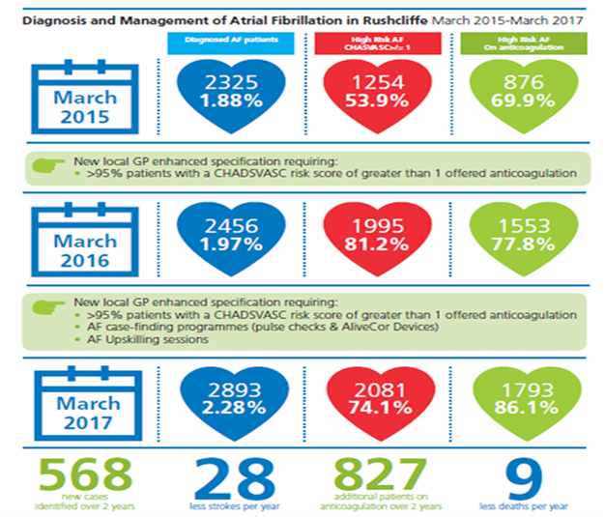

1. **Mid Nottinghamshire CCGs:** The Devon Predictive tool is used to stratify data and provide a risk score; patients scoring 70% or above receive coordinated care through monthly multidisciplinary team meetings.

**Geographical area:** Mid-Nottinghamshire

**Purpose:** To use data to identify people most at risk of readmission to hospital and to intervene with MDT to reduce their risk of subsequent admissions.

**Method:**

* Stratification based on acute data risk score shared through the primary care portal and case finding register
* 2013 mobilised 8 Integrated Care Teams
* 2014 all 41 practices are part of an integrated primary care approach
* SOP for MDT to review all patients with 70% + risk of further hospital admission

**Outcomes:**

Mr X was identified as having a risk score of 97%. In the previous four month period, he had been admitted to hospital on 3 occasions linked to his respiratory condition.

Mr X’s case was discussed at the MDT meeting and specific input from the Respiratory Nurse and Mental Health Nurse was agreed. In the following four months Mr X had no hospital attendances or admissions. Mr X’s risk score reduced to 84% based on the interventions, and he will remain under the care of the Local Integrated Care Team until he builds further confidence to self-manage.

System:

* Cost of existing admissions: £4113 (based on £1371 per short stay admission).
* Pattern of admission: likely to have had 3 further admissions without intervention.
* Saving to the system based on this planning assumption: £4113 (based on £1371 per short stay admission).
* Positive impact seen on unplanned care demand and acute trust patient flow.

Mr X:

* Remains under the care of GP and Local Integrated Care Team with monthly review.
* Support to manage physical and psychological impact of his condition and avoid exacerbation of condition.

Savings:

* In 2016-17, Mid-Notts reported gross savings of £6.151m through reduced NEL admissions, and overall net savings for the vanguard were positive £1.179m. The model is predicted to generate an ROI of 123% over the five years from 16-17 to 20-21.

**Figure 5:**

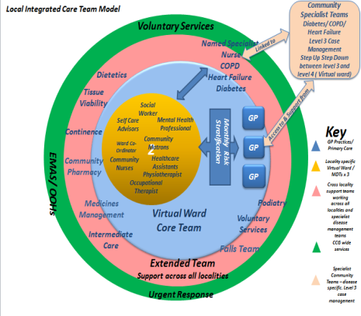

1. **Southern Hampshire:** Southern Hampshire has worked with Milliman to develop a five year forecast model tailored to the needs of their local population using their Chronic Condition Hierarchical Groups tool.

**Geographical area:** Hampshire

**Purpose:** CCGs have used the Milliman analysis to plan services and to develop cost improvement plans.

**Method:**

* Milliman used their current activity and expenditure and 5 year forecast activity and expenditure, based on actuarial analysis and council forecasts across the local area.
* This data was benchmarked against a ‘well managed’ health care system from the USA. They then used 75% activity levels of the ‘well managed system’ as the benchmark to compare against the CCG area’s activity levels to identify where the outliers are at diagnosis level and at Clinical Conditions Hierarchy Group (CCHG) level.
* This analysis was then used to develop a population profile to show how much each condition differs from the benchmark and what savings opportunity is available.
* In Gosport life expectancy for men is 79.9 years; for women it is 83.2, however, men have 13.8 years of ill health and women have16 years of ill health. The highest needs relate to respiratory conditions. Carousel clinics have been put in place to improve early diagnosis and optimise treatment.

**Outcomes:**

* Acute Visiting service: Initiated in April 2017 in 7 GP Practice populations – c. 60,000 patients. Since GO Live the service has seen 573 Patients and claims avoidance of 46 admissions (data to 30/06/17).
* Carousel clinic showed of 1,436 patients reviewed, 460 poorly controlled; hospital admissions reduced from 6 to zero; GP emergency appointments 61 to 31.
* Care homes team mobilised and an initial intervention has taken place in one of the care homes (50 frail patients) in the locality and will be rolled out to further care homes during Q2.

**Figure 6:**



Savings based on potentially avoidable admissions (F&G CCG) Millimans 75% well managed benchmark.

1. **Connected Care Partnership:** Using risk stratification tools as a method of case finding.

**Geographical area:** West Birmingham

**Purpose**: To identify people for whom a multi-disciplinary approach to care planning can reduce the risk of adverse events and unplanned use of secondary care services.

**Method:**

Electronic Frailty Index (eFI)

* Protocol and searches were developed to produce a frailty score using the eFI algorithm in EMIS web for patients over 65.
* Moderately and severely frail patients without a current care plan were identified.
* Patient contacted and assessed at home - two assessment pathways trialled.
* Wellbeing coordinator assesses using EasyCare assessment with access to nurse for advice or further assessment if indicated.
* Community nurse assesses with referral to wellbeing coordinator when social issues are identified.
* Goals and actions agreed with patient (and carer where appropriate).
* Both pathways have a possibility of discussion within the primary care huddle with referral to cross organisation MDT if needed.

Aristotle risk stratification tool, provided by Midlands and Lancs CSU:

* Top 2% with increasing risk scores.
* Patients with existing care plans excluded.
* Patients discussed at MDT meeting (Members from primary care, community health, mental health and wellbeing services).
* MDT assessment and care planning implemented.

**Outcomes:**

* Patient X – in top 2% and not adhering to diabetes management plan.
* Joint assessment by community nurse and wellbeing coordinator.
* Problems identified – ex-services with PTSD, inappropriate housing, insufficient funds, poor understanding of diabetes, social anxiety.
* Persons / services involved in developing and implementing plan with patient-wellbeing coordinator, diabetes nurse specialist, community nurse, support coordinator for ex-forces personnel, homeless peoples nurse, housing association, mental health services.
* Actions- Insulin regime changed, rehoused, benefits reviewed, referred for counselling, supported to attend diabetes reviews at practice and in secondary care, supported to attend dental appointments.
* No further emergency attendances to date.

**Figure 7:**

# Learning from key challenges

1. **Vanguard lessons learned - risk stratification tools**

The Adjusted Health Group (ACG) risk stratification tool is a software application that helps you to use predictive modelling to risk stratify the health needs of your local population.

Overview of tool:

* Uses multi-level logistic regression (weighting the predictive influence of independent variables) in order to predict future healthcare service utilisation over a defined time period.
* Augments the model with an evidence-base from international research, to refine the weight of predictive factors.
* Can combine secondary and primary care data.
* The tool was developed using the whole health spectrum including healthy and healthier segments of the population.

Potential uses of the ACG model:

* Combined primary and secondary care data may enhance predictive sensitivity and specificity. However, information governance may provide a challenging barrier to implementing this in practice.

The usability of the tool and interpretation of the results has proved problematic in practice, as:

* Clinicians have provided feedback that the interface is not user-friendly.
* The tabular output can be difficult to interpret and therefore makes interventions more difficult to tailor.
* ACGs do not integrate with clinical systems; therefore there is some development work to automate data loading. A lack of interoperability may necessitate manual data updates.

1. **Vanguard lessons learned – culture and leadership**

Is there consistency in operationalising risk stratification process and insights?

* The use of risk stratification is in play across all of Dudley’s GP practices but there is inconsistency in approach. The frequency of updating risk stratification lists varies considerably.

How flexible is the risk stratification process (automated top 2% or dynamic interrogation)?

* In Dudley, some MDTs are looking beyond the top 2% but others not. Some use a different Risk Stratification tool for triangulation purposes that includes secondary care data only, while others do not.
* Generally, flexibility is key as no risk stratification tool or process can generate “perfect” targeting, due to a number of other contributing factors. Risk stratification is a helpful enabler, but delivery of care is what generates the impact for individuals.

Are the required risk stratification knowledge and skills available at the right points within the system to optimise insight and case finding/targeting?

* GP practices can use risk stratification as a case finding panacea only on focus on the top 2% of risk. One of the gaps in the system is having exploratory analytical capability at the ‘coal face’, so that data can be interrogated on a bespoke practice level incorporating demographic characteristics and taking into consideration the highly variable service usage by GP practice.
* Analytical skills and knowledge that could facilitate a more dynamic interrogation of the practice populations does not currently exist at the GP Practice or MDT level. A central capacity and capability is therefore required but this is often thwarted by access not being currently being granted, identify or re-identify at the patient level.
* Generally, most professionals within the system understand risk stratification but can require support to ensure this is implemented effectively.

How could current Risk Stratification be improved?

* Risk stratification is accepted as a concept but not always systematically implemented on the front line. The use of risk stratification needs to be systemised in order for this to become business as usual.
* Risk stratification needs to be augmented by the inclusion of more characteristics, such as demographic factors influencing service access and usage. In addition, factorial weightings need to be analysed and modified at the Practice level in order to make stratification and prediction more accurate for MDT use.

1. **Predictive modelling in risk stratification**

There are three NHS tools pertaining to risk stratification; Patients at Risk of Re-hospitalisation, the Combined Predictive Model and Patients at Risk of Re-hospitalisation over 30 days and a range of commercial tools.

Three NHS models have been developed – Patients at Risk of Re-hospitalisation (PARR), the Combined Predictive Model (CPM) and the Patients at Risk of Re-hospitalisation over 30 days (PARR-30). All are free to use, and have been shown to be accurate predictors of risk.

CPM can also predict risk for patients who have not had an emergency admission in the last 24 months. Active promotion of these tools ceased in 2011.

* **Not for profit model - QAdmissions®:**

QAdmissions® is a clinical risk prediction tool which calculates an individual's risk of emergency admission to hospital over the next one or two years. The algorithm can be used to identify patients at high risk of an emergency admission so that they can be assessed in more detail to help reduce their risk. The algorithm runs off data that:

a.) can be automatically populated using data solely from GP computer systems and so provides an expedient practical alternative where primary care data are not routinely linked to secondary care data and

b.) incorporates clinically relevant variables which the health professional can then follow up.

* **Commercial Model example- Milliman:**

Milliman provides services ranging from actuarial consulting, benchmarking and enterprise risk management. They have products which include internal benchmarking tools:

* Milliman Advanced Risk Adjusters (MARA) is a suite of risk adjustment tools for population analysis suited for budgeting, pricing and underwriting, payment, stratifying risks, and many other predictive modelling applications for the health insurance industry.
* The Chronic Conditions Hierarchical Groups (CCHG) is a clinical care-based methodology for enhancing population health management based on patient and chronic condition information. It is designed to more accurately identify cost trend drivers and effectively allocate disease and care management resources. In the NHS, CCHGs have been used to help commissioners understand the clinical risk associated with a population, within the changing payment models / population-based budgets. They can also support risk stratification for care management, and other risk adjustment for measuring utilisation, clinical quality and outcomes.
* **Commercial Model example - Optum:**

The Optum risk stratification tool for the NHS, HealthNumerics-RISC®, predicts the risk of patients having unplanned chronic admissions in a 12 month period. HealthNumerics-RISC® is a dynamic tool that takes data from multiple sources including primary and secondary care, to perform a risk stratification of the entire population of a health care organisation. HealthNumerics-RISC® supports proactive management of the health of a population, targeting resources on the patients with the greatest need, and allows for prioritisation of community based preventative care and aids in the development of strategies to reduce emergency admissions. It provides timely, comprehensive information to clinicians to support interventions for those patients most in need, ensuring better long term patient outcomes whilst driving down costs. HealthNumerics-RISC® can be used to identify patients with long term conditions for potential case management and for commissioners to analyse care pathways.

# Other useful resources

A product describes the uses and benefits of risk stratification as a tool for supporting care planning and personalised care. It summarises the current research and evidence around risk stratification, and provides practical guidance for implementing risk stratification supported by case studies of healthcare organisations that have run of risk stratification programmes.

|  |  |  |
| --- | --- | --- |
| Key resource | About | Link |
| Risk Stratification Product | A learning and impact study on risk stratification produced by the NHSE Operational Research and Evaluation team. Includes a review of the core methods, examines the existing literature, and outlines key lessons learnt from the vanguards. |  |
| ORET Risk Stratification Learning and Impact | A learning and impact study on risk stratification produced by the NHSE Operational Research and Evaluation team. Includes a review of the core methods, examines the existing literature, and outlines key lessons learnt from the vanguards. |  |
| Risk Stratification Case Study Template | A case study on the use of risk stratification to identify patients potentially suitable for extensive care and enhanced primary care in Fylde Coast MCP. |  |
| Choosing predictive risk model guide for commissioners | This Nuffield Trust guide presents the key principles of predictive modelling for commissioners and public health specialists in England. | <https://www.nuffieldtrust.org.uk/files/2017-01/choosing-predictive-risk-model-guide-for-commissioners-web-final.pdf> |
| Next steps risk stratification in the NHS | Next steps guide to risk stratification in the NHS. | <https://www.england.nhs.uk/wp-content/uploads/2015/01/nxt-steps-risk-strat-glewis.pdf> |
| NHS England blog | NHS England’s Chief Data Officer Geraint Lewis’ blog on why population health analytics will be vital for vanguards. | <https://www.england.nhs.uk/blog/geraint-lewis-2/> |

# Glossary

**Accountable Care System**: a system where all local organisations responsible for healthcare make collective decisions about healthcare for their specific population, using a shared budget.

**Population health management:** population health management is the analysis and segmentation of the needs of a population and the design of clinical and other interventions to prevent illness or acute deterioration.

**Risk stratification:** risk stratification segments the population and attributes cost, enabling the system to identify greatest opportunities for changing the delivery of care

# For further information

**For further information please contact:**

**James Smith**

Project Manager, System Transformation Group, NHS England

**e: james.smith31@nhs.net**