Overview
The first step in population health intelligence is to understand the needs of the population as a whole, as well as the sub populations within it. Joint strategic needs assessments (JSNAs) are a powerful source of population health insights, being the mechanism by which health and wellbeing boards analyse the health and social care needs of their local population.
We used JSNAs as source documents to determine overlapping population health needs for the eight boroughs of North West London (NWL): Brent, Ealing, Harrow, Hounslow, Hillingdon, Kensington & Chelsea, Hammersmith & Fulham and Westminster City Council.
This approach may have utility for Integrated Care Systems (ICS) seeking to design services that address actual population health needs and inequalities – as identified by their constituent CCGs and local authorities.
Scope
We asked the following questions:
- Which population health data are reported in JSNAs?
- Which population health needs are identified as priorities by the health and wellbeing boards?
- Where are the areas of overlap in population health needs identified across NWL boroughs?
- [Exploratory] To what extent are local priorities aligned with delivery areas listed in the NWL Sustainability and Transformation Plan (STP, 2016-2021)?

Source materials
All NWL JSNAs published after 2014 (inclusive, Table 1) were included in this review. JSNA chapters published before 2014, or chapters that have been superseded, were excluded.
Data extraction
The following information was extracted from each NWL borough’s JSNAs:
- Population health issues that are identified as a local gap or need. For example: inequality of outcomes for different population segments within the borough, or outcomes that are worse than national or regional benchmarks
- Population health issues are specifically flagged as local priorities or “key challenges”
- Presence or absence of data reporting in situations where a population health issue was reported as a need or priority for another NWL borough
A shared population health need for NWL was defined as an area where a need was identified in ≥4 JSNAs and/or prioritised in ≥2 JSNAs.
Summary of findings for NWL
Based on the JSNAs of eight NWL boroughs, we identified shared population health needs in the following areas:
- Wellbeing and prevention: Obesity (adult and child), physical activity, smoking, substance misuse.
- Clinical: Type 2 diabetes, cancer (screening), tuberculosis, severe physical disability
- Mental and sexual health: Severe/enduring mental illness, sexually transmitted infection (particularly HIV)
- Social: Supported housing (incl. learning disability/autism)
- Wider determinants of health: Crime (incl. female genital mutilation, domestic violence, hate crimes), migrant/asylum seeker status, poverty (incl. fuel poverty, child poverty), housing (incl. affordability, availability)
- Children & young people: Number of A&E visits, children with SEN (incl. transfers of care), looked after children.
- Older people: Dementia care
Alignment with the STP
As an exploratory extension study, we compared the list of ‘shared population health needs with delivery areas in the NWL STP (2016-2021, Figure 1). Alignment was ranked as follows for each of the five STP delivery areas:
- Close alignment – STP delivery area directly addresses a population health priority identified in NWL JSNAs
- Partial alignment – STP delivery area partially addresses or references a need or inequality identified in NWL JSNAs
- Limited alignment/Not applicable – STP delivery area does not address a need or inequality identified in NWL JSNAs (in some cases, STP activities would not be applicable at a CCG/local authority level and so alignment would not be expected)
We found that several of the NWL population health needs were addressed by existing STP delivery areas; however, there was scope for closer alignment (Figure 1).
Next steps
Work is currently being undertaken by system leaders to refresh the STP, as priorities may have changed since the JSNAs were first published. To truly help and inform this process, analysis alongside engagement will be key.
Resources
Guides to the JSNA process and best practice methods are available from:
Statutory Guidance on Joint Strategic Needs Assessments and Joint Health and Wellbeing Strategies (Department of Health, 2012)
Joint Strategic Needs Assessment: Data Inventory (Local Government Group)
The joint strategic needs assessment: A vital tool to guide commissioning (NHS Confederation Briefing, July 2011)

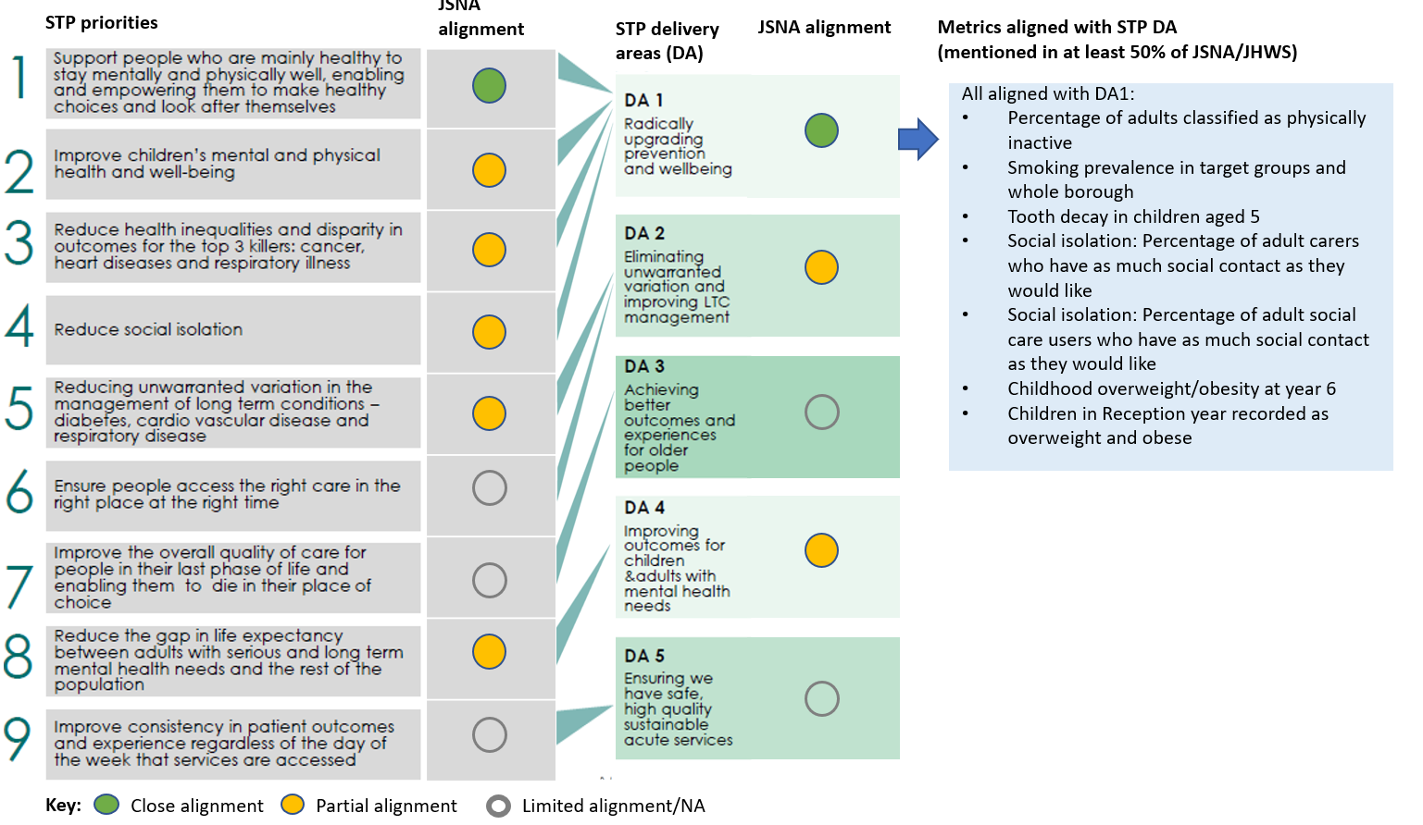
Figure 1 Alignment of 8 JSNAs with priorities and delivery areas listed in the NWL STP, 2016-2021.
Figure 1 Alignment of 8 JSNAs with priorities and delivery areas listed in the NWL ST Figure 1 Alignment of 8 JSNAs with priorities and delivery areas listed in the NWL STP, 2016-2021.
P, 2016-2021.

Table 1. Source materials
Document reviewed | Available from [accessed August 2018]
The Hounslow Story: JSNA summary document (August 2017) | https://www.hounslow.gov.uk/downloads/download/107/joint_strategic_needs_assessment
Hillingdon JSNA priority themes and factsheets online (undated) | https://www.hillingdon.gov.uk/article/21876/Main-report
Harrow JSNA (v7 2015-2020) | http://www.harrow.gov.uk/downloads/file/7745/jsna_2015-2020
Ealing JSNA chapters reviewed:  - 2014 Executive summary  - Dementia (2015)  - Sensory impairment (2016)  - Learning disability (2016)  - Children and young people (2016)  - Housing, homelessness and rough sleepers (2016)  - Carers (2016)  - Children’s oral health (2017)  - Autism spectrum disorder (2017)  - Musculoskeletal health (2018)  - End of life care (2018)  Mental health (2018) | https://www.ealing.gov.uk/downloads/download/1018/ealing_joint_strategic_needs_assessment_jsna_2014  https://www.ealing.gov.uk/downloads/download/4673/joint_strategic_needs_assessment_jsna_2018
Brent JSNA Overview Report: 2015/16 | https://www.brent.gov.uk/jsna  https://intelligence.brent.gov.uk/BrentDocuments/JSNA%202015%20-%20Brent%20Overview%20Report.pdf?_ga=2.69321488.1403009581.1534016594-484053254.1532532346
K&C/WCC/H&F JSNA chapters reviewed:  - Children with special educational needs (Jul 2018)  - Young Adults JSNA (Jan 2017)  - Housing and Care (Sep 2016)  - Childhood obesity (Jan 2016)  - End of life care (Jan 2016)  - Dementia (Oct 2015)  - Physical activity (May 2014)  - Child poverty (Apr 2014)  - Substance misuse/offender health (Mar 2014)  - Tuberculosis (Mar 2014)  - Highlights report 2013-14  - Learning disabilities (Jan 2014) | https://www.jsna.info/JSNAs

